Newsstand / Shopify Integration

Setup Guide

**Introduction** **1**

**Setting up Webhooks** **1**

Connecting With Newsstand 2

**Product Setup** **3**

Adding a Product 3

Product Variants 4

**Altering an Existing Setup** **6**

# Introduction

This document will provide instructions for integrating your Shopify site with the Newsstand API so that orders placed through your site can be automatically sent to and fulfilled by Newsstand.

This document will provide information on setting up webhooks and products within your Shopify site so that they can be properly accepted by the Newsstand API.

# Setting up Webhooks

To get to the webhooks menu within Shopify you will first want to go to Settings → Notifications. Scroll down to the section labelled ‘Webhooks’ and click on ‘Create webhook’.

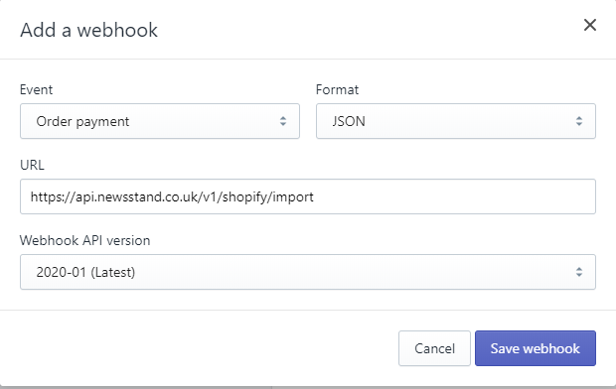

You will be presented with a dialog box for entering the details of the webhook.

Ensure that the ‘Event’ is set to ‘Order payment’ and that the ‘Format’ is set to ‘JSON’. Set the Webhook API version to ‘2020-01’.

Depending on whether you are testing or in production, you will want to use a different webhook URL:

|  |  |
| --- | --- |
| Version | Webhook URL |
| Test | <https://api.newsstand.co.uk/v1/shopify/import/test> |
| Live | <https://api.newsstand.co.uk/v1/shopify/import> |

## Connecting With Newsstand

After this is done you will be able to see your created webhook on display.

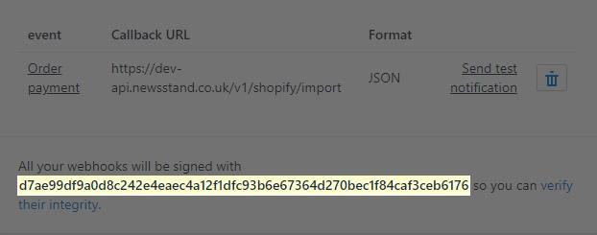

Below the webhook you will see a unique ‘Hash Key’. In order for your orders to be successfully processed by Newsstand you will need to connect this ‘Hash Key’ to your publisher account.

To do this you will need to log into your publisher account that can be located at <https://portal.newsstand.co.uk/>. If you do not currently have an account, please contact the Newsstand team who will be able to assist you.

After signing into your publisher account you will need to create an ‘API Key’. This can be done via the API Keys page at <https://portal.newsstand.co.uk/apiKeys>. Once you are on this page you will want to add the key by clicking ‘Add a New Key’, choosing ‘Shopify’ from the dropdown and entering your ‘Hash Key’ as shown below.

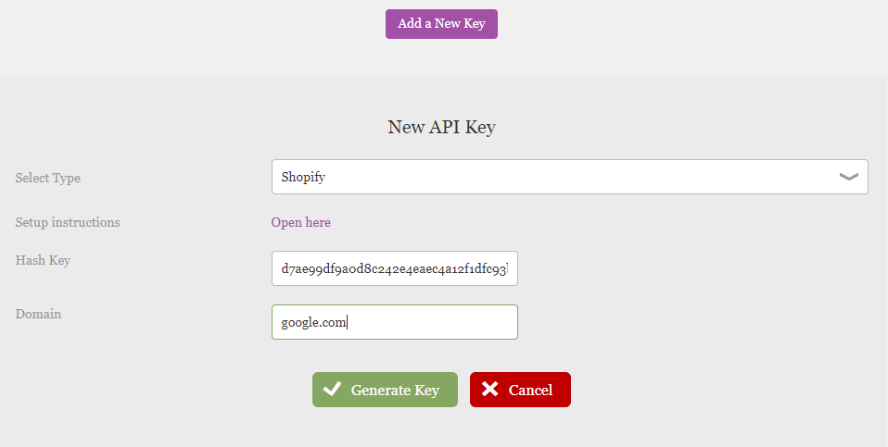

Note that the domain should be the domain for your shopify site and this is how our API will identify that the order is coming from you.

After doing this click Generate Key and your ‘Hash Key’ will be saved within the Newsstand system and you will be able to start sending orders.

# Product Setup

For Newsstand to recognise an added product it must have a ‘Starting issue variation’ of [This/Next/Previous]. The value for the ‘Number of issues’ refers to the length of the subscription being purchased.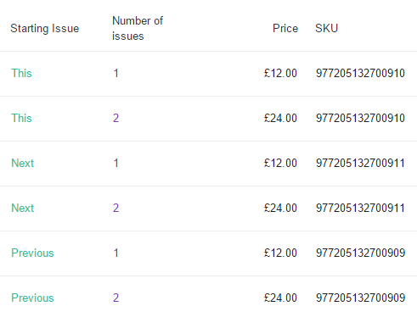

The EAN for each issue must also be entered into the SKU field as shown.

## Adding a Product

Within Shopify, select the ‘Product’ icon, illustrated by a gift tag from the main menu to open the products page.

Click the ‘Add Product’ button located at the top right of the screen. This will take you to a page where you can enter the details of the magazine for sale.

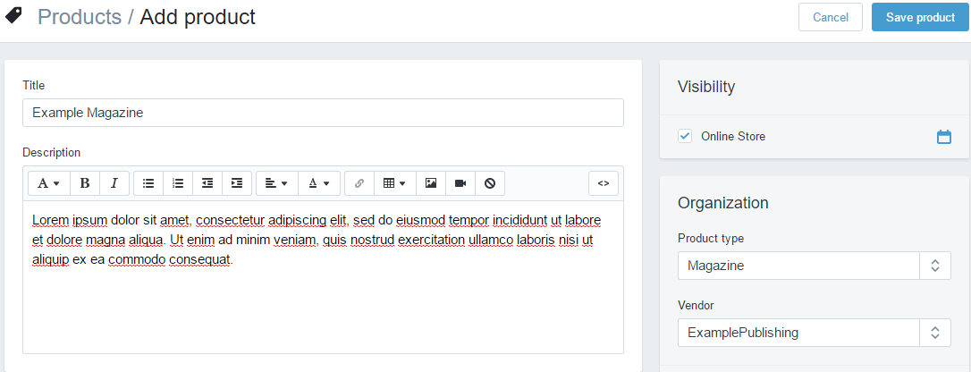

## 

## Product Variants

After setting up the magazine you will need to add the issues to that magazine. This is done in the form of product variants. You will want to ignore the ‘Pricing’ section of the product for now and go straight to the ‘Variants’ section.

Check the ‘This product has multiple options’ checkbox and add 2 options. One for ‘Start Issue’ and a second for ‘Number of Issues’.

Add ‘This’, ‘Next’ and ‘Previous’ to the ‘Start Issue’ option. Then for ‘Number of Issues’, add the various subscription lengths that you want to be available to purchase.

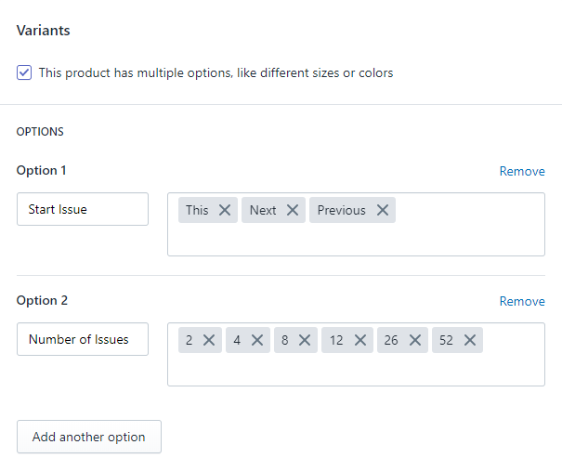

With these options added a table will appear below containing each possible variant. You will need to add the Price and SKU (Issue EAN) for each variant as shown below:

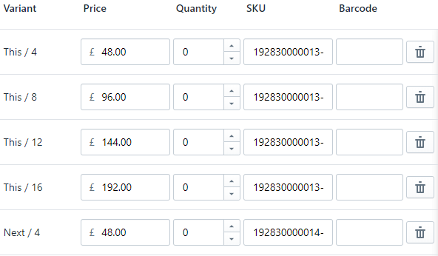

As each new issue is released you will need to ensure that the SKUs and Prices are updated to match.

After all Prices and SKUs have been entered click ‘Save product’ at the bottom of the page.

# Altering an Existing Setup

If you already have a magazine setup, you may need to make some changes to it in order for it to integrate with the Newsstand system.

If you have already filled in the pricing section for the product, this will need to be removed and replaced with the variant system described in the previous section.

You will also have to remove any variants that do not use the ‘Start Issue’, ‘Number of Issues’ options setup. (Please refer to the ‘Product Variants’ section for more details on this)

