Newsstand / WooCommerce Integration

Setup Guide

**Introduction** **1**

**API Key** **2**

**Setting up Webhooks** **3**

Order Created Webhook 3

Payment Complete Webhook 3

**Products** **4**

Adding a New Product 4

Product Attributes 4

Product Variants 5

Maintenance 5

# Introduction

This document will provide instructions on integrating your WordPress site with the Newsstand API so that orders placed through your site can be automatically sent to and fulfilled by Newsstand.

This document will provide information on setting up webhooks and products within your WordPress site so that they can be properly accepted by the Newsstand API.

# 

# API Key

In order to use WooCommerce webhooks with Newsstand you will need an API key. In order to get your API key you will need to log into your publisher account at <https://portal.newsstand.co.uk>. If you do not currently have an account, please contact the Newsstand team who will be able to assist you.

After signing into your publisher account you will need to create an ‘API Key’. This can be done via the API Keys page at <https://portal.newsstand.co.uk/apiKeys>. Once you are on this page you will want to add the key by clicking ‘Add a New Key’, choosing ‘WooCommerce’ from the dropdown and clicking ‘Generate Key’ as shown.

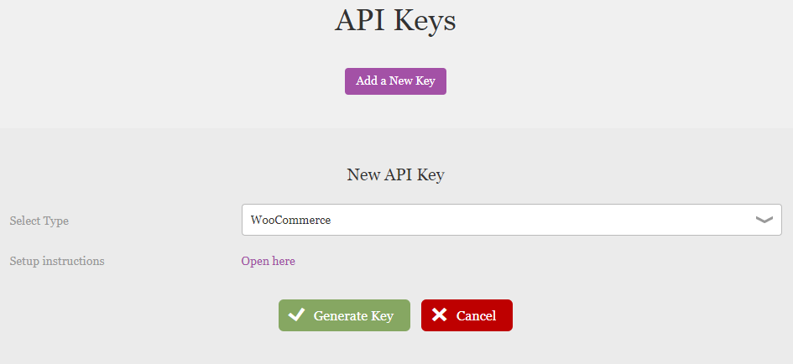

An API Key will be generated for you that you will be able to view on this page. You will need this Key when creating your webhooks. This page will also provide the Webhook URLs that you will need when creating your webhooks. (Note that the urls below are only for example purposes).

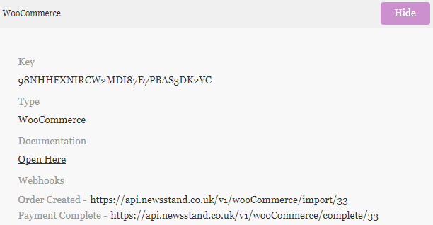

# Setting up Webhooks

First, you will want to open the WooCommerce settings menu. Select WooCommerce from the menu on the left and then Settings.

From the settings page select the ‘Advanced’ tab and then click on the link ‘Webhooks’.

## Order Created Webhook

First, you will want to create the ‘Order Created’ webhook. This can be done by clicking ‘Add webhook’ from the Webhooks menu.

Fill in the form using the following options and then click ‘Save webhook’.

|  |  |
| --- | --- |
| **Option** | **Value** |
| Name | *Whatever you want* |
| Status | Active |
| Topic | Order Created |
| Delivery URL | *Order Created Webhook URL from API Keys page* |
| Secret | *API Key from API Keys page* |
| API Version | Legacy API v3 (depreciated) |

## Payment Complete Webhook

Second, you will want to create the ‘Payment Complete’ webhook. Click the ‘Add webhook’ button again. Fill in the form using the following options and then click ‘Save webhook’.

|  |  |
| --- | --- |
| **Option** | **Value** |
| Name | Payment Complete |
| Status | Active |
| Topic | Action |
| Action Event | woocommerce_payment_complete |
| Delivery URL | *Payment Complete Webhook URL from API Keys page* |
| Secret | *API Key from API Keys page* |
| API Version | WP REST API Integration v2 |

# Products

After creating your webhooks you are ready to add magazines and issues to your site. This is done in the form of ‘Products’. Products must be set up in a particular way to ensure that they are compatible with the Newsstand system.

## Adding a New Product

Select ‘Add New’ from the Products sub menu. Enter the title of the magazine and any description for the magazine. Then scroll down to the ‘Product data’ section.

Select ‘Variable product’ from the drop down and enter the magazine’s EAN into the SKU field in the inventory tab.

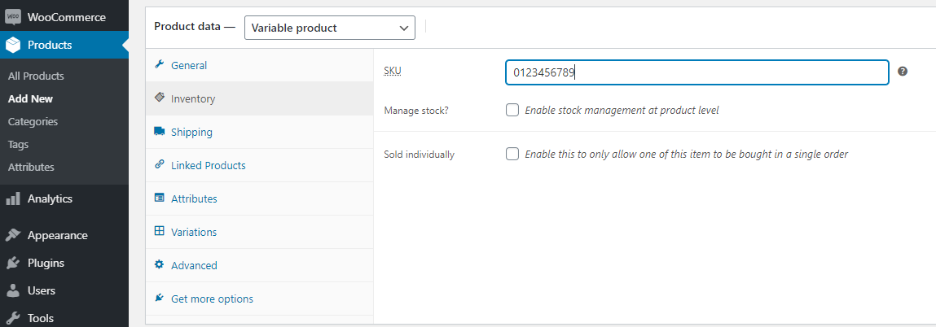

### Product Attributes

Go to the ‘Attributes’ tab, select ‘Custom product attribute’ and click ‘Add’. Add ‘Frequency’ and ‘StartIssue’ attributes ensuring that the ‘Used for variations’ checkbox is checked for both attributes.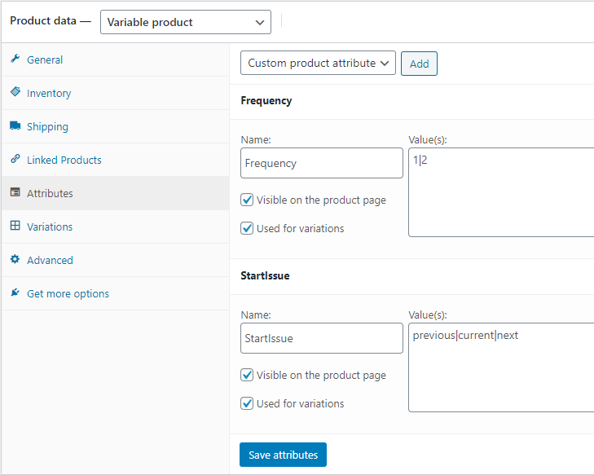

‘Frequency’ values are used to indicate the subscription length options. Each value should be separated by a pipe ‘|’ symbol.

Values for ‘StartIssue’ will allow the customer to choose which issue they wish to be the first of their subscription. Again, each value should be separated by a pipe symbol. The valid values for this attribute are previous, current and next.

### Product Variants

After adding the product attributes you will want to go to the ‘Variations’ tab, select ‘Create variations from all attributes’ and click ‘Go’.

This will create a variant for each combination of ‘Frequency’ and ‘StartIssue’ value that you set in the ‘Attributes’ tab.

Once the variants have been created you will need to you through each variant and add EAN and price details to each variant. You will need to put the issue EAN into the SKU field.

Please note that WooCommerce does not allow duplicate SKU codes so you will need to put the issue EAN followed by a dash and then some unique reference.

For example, if you have 2, 4, 6 and 8 length subscriptions and an issue EAN of 0123456789 your SKU codes could be 0123456789-2, 0123456789-4 etc.

The price field should reflect the price of the entire subscription.

## Maintenance

Each time a new issue is released all of the SKUs for the variants will need to be updated. This needs to be done to ensure that the correct issues are ordered as the start of the subscription.